**Q - 1: WHAT IS COMPUTER GRAPHICS? WRITE DOWN THE APPLICATION OF CG.**

ANS ->

Computer graphics deals with creation, manipulation and storage of different type of images and objects.

Some of the applications of computer graphics are:

**Computer Art**:

Using computer graphics we can create fine and commercial art which include animation packages, paint packages. These packages provide facilities for designing object shapes and specifying object motion.Cartoon drawing, paintings, logo design can also be done.

**Computer Aided Drawing**:

Designing of buildings, automobile, aircraft is done with the help of computer aided drawing, this helps in providing minute details to the drawing and producing more accurate and sharp drawings with better specifications.

**Presentation Graphics:**

For the preparation of reports or summarising the financial, statistical, mathematical, scientific, economic data for research reports, managerial reports, moreover creation of bar graphs, pie charts, time chart, can be done using the tools present in computer graphics.

**Entertainment**:

Computer graphics finds a major part of its utility in the movie industry and game industry. Used for creating motion pictures , music video, television shows, cartoon animation films. In the game industry where focus and interactivity are the key players, computer graphics helps in providing such features in the efficient way.

**Education**:

Computer generated models are extremely useful for teaching huge number of concepts and fundamentals in an easy to understand and learn manner. Using computer graphics many educational models can be created through which more interest can be generated among the students regarding the subject.

**Training**:

Specialised system for training like simulators can be used for training the candidates in a way that can be grasped in a short span of time with better understanding. Creation of training modules using computer graphics is simple and very useful.

**Visualisation**:

Today the need of visualise things have increased drastically, the need of visualisation can be seen in many advance technologies , data visualisation helps in finding insights of the data , to check and study the behaviour of processes around us we need appropriate visualisation which can be achieved through proper usage of computer graphics

Image Processing:

Various kinds of photographs or images require editing in order to be used in different places. Processing of existing images into refined ones for better interpretation is one of the many applications of computer graphics.

**Machine Drawing**:

Computer graphics is very frequently used for designing, modifying and creation of various parts of machine and the whole machine itself, the main reason behind using computer graphics for this purpose is the precision and clarity we get from such drawing is ultimate and extremely desired for the safe manufacturing of machine using these drawings.

**Q - 2: CATHODE RAY TUBE(CRT).**

ANS ->

A cathode-ray tube (CRT) is a specialized vacuum tube in which images are produced when an electron beam strikes a phosphorescent surface. Most desktop computer displays make use of CRTs. The CRT in a computer display is similar to the "picture tube" in a television receiver.

A cathode-ray tube consists of several basic components, as illustrated below. The electron gun generates an arrow beam of electrons. The anodes accelerate the electrons. Deflecting coils produce an extremely low frequency electromagnetic field that allows for constant adjustment of the direction of the electron beam. There are two sets of deflecting coils: horizontal and vertical.(In the illustration, only one set of coils is shown for simplicity.) The intensity of the beam can be varied. The electron beam produces a tiny, bright visible spot when it strikes the phosphor-coated screen.

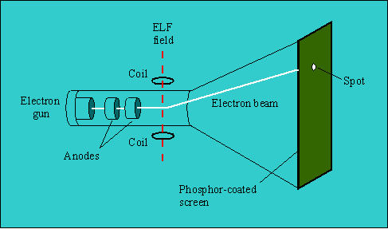

To produce an image on the screen, complex signals are applied to the deflecting coils, and also to the apparatus that controls the intensity of the electron beam. This causes the spot to race across the screen from right to left, and from top to bottom, in a sequence of horizontal lines called the raster. As viewed from the front of the CRT, the spot moves in a pattern similar to the way your eyes move when you read a single-column page of text. But the scanning takes place at such a rapid rate that your eye sees a constant image over the entire screen.

The illustration shows only one electron gun. This is typical of a monochrome, or single-color, CRT. However, virtually all CRTs today render color images. These devices have three electron guns, one for the primary color red, one for the primary color green, and one for the primary color blue. The CRT thus produces three overlapping images: one in red (R), one in green (G), and one in blue (B). This is the so-called RGB color model.

In computer systems, there are several display modes, or sets of specifications according to which the CRT operates. The most common specification for CRT displays is known as SVGA (Super Video Graphics Array). Notebook computers typically use liquid crystal display. The technology for these displays is much different than that for CRTs.

**Q - 3: DIFFERENCE BETWEEN RANDOM SCAN SYSTEN & RASTER**

**SCAN SYSTEM.**

ANS ->

| **RANDOM SCAN SYSTEM** | **RASTER SCAN SYSTEM** |
| --- | --- |
| It has high Resolution. | Its resolution is low. |
| It is more expensive. | It is less expensive. |
| Any modification if needed is easy. | Modification is tough. |
| Solid pattern is tough to fill | Solid pattern is easy to fill |
| Refresh rate depends or resolution | Refresh rate does not depend on the picture. |
| Only screen with view on an area is displayed. | Whole screen is scanned. |
| Beam Penetration technology come under it. | Shadow mark technology came under this. |
| It does not use interlacing method. | It uses interlacing |
| It is restricted to line drawing applications | It is suitable for realistic display. |

**Q - 4: EXPLAIN COLOR CRT MONITORS.**

ANS ->

***Color CRT Monitors:***

The CRT Monitor display by using a combination of phosphors. The phosphors are different colors. There are two popular approaches for producing color displays with a CRT are:

* Beam Penetration Method
* Shadow-Mask Method

1. **Beam Penetration Method:**

The Beam-Penetration method has been used with random-scan monitors. In this method, the CRT screen is coated with two layers of phosphor, red and green and the displayed color depends on how far the electron beam penetrates the phosphor layers. This method produces four colors only, red, green, orange and yellow. A beam of slow electrons excites the outer red layer only; hence screen shows red color only. A beam of high-speed electrons excites the inner green layer. Thus screen shows a green color.

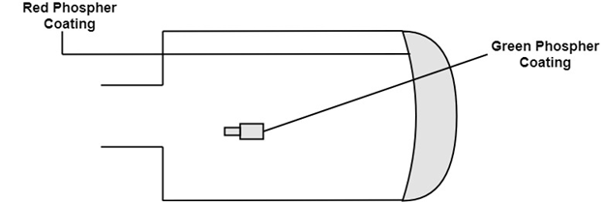

**Advantages**:

* Inexpensive

**Disadvantages**:

* Only four colors are possible
* Quality of pictures is not as good as with another method.

2. **Shadow-Mask Method**:

Shadow Mask Method is commonly used in Raster-Scan System because they produce a much wider range of colors than the beam-penetration method.

It is used in the majority of color TV sets and monitors.

Construction: A shadow mask CRT has 3 phosphor color dots at each pixel position.

One phosphor dot emits: red light

Another emits: green light

Third emits: blue light

This type of CRT has 3 electron guns, one for each color dot and a shadow mask grid just behind the phosphor coated screen.

Shadow mask grid is pierced with small round holes in a triangular pattern.

Figure shows the delta-delta shadow mask method commonly used in color CRT system.

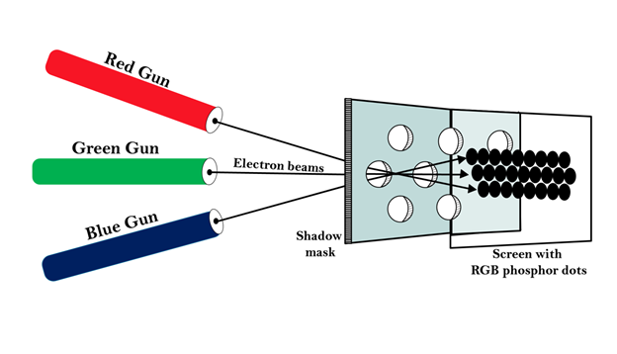

Working: Triad arrangement of red, green, and blue guns.

The deflection system of the CRT operates on all 3 electron beams simultaneously; the 3 electron beams are deflected and focused as a group onto the shadow mask, which contains a sequence of holes aligned with the phosphor- dot patterns.

When the three beams pass through a hole in the shadow mask, they activate a dotted triangle, which occurs as a small color spot on the screen.

The phosphor dots in the triangles are organized so that each electron beam can activate only its corresponding color dot when it passes through the shadow mask.

Inline arrangement: Another configuration for the 3 electron guns is an Inline arrangement in which the 3

electron guns and the corresponding red-green-blue color dots on the screen, are aligned along one scan line rather of in a triangular pattern.

**Advantage**:

* Realistic image
* Million different colors to be generated
* Shadow scenes are possible

**Disadvantage**:

* Relatively expensive compared with the monochrome CRT.
* Relatively poor resolution
* Convergence Problem

**Q - 5: EXPLAIN DVST.**

ANS -> Conceptually the Direct View Storage Tube (DVST) behaves like a CRT with highly persistent phosphor. Pictures drawn on there will be seen for several minutes (40-50 minutes) before fading. It is similar to CRT as far as the electronic gun and phosphor-coated mechanisms are concerned. But instead of the electron beam directly writing the pictures on the phosphor coated CRT screen, the writing is done with the help of a fine-mesh wire grid.

The grid made of very thin, high quality wire, is located with a dielectric and is mounted just before the screen on the path of the electron beam from the gun. A pattern of positive charges is deposited on the grid and this pattern is transferred to the phosphor coated CRT by a continuous flood of electrons. This flood of electrons is produced by a “flood gun” (This is separate frame the electron gun that produces the main electron beam).

Just behind the storage mesh is a second grid called the collector. The function of the collector is to smooth out the flow of flood electrons. Since a large number of electrons are produced at high velocity by the flood gun, the collector grid, which is also negatively charged reduces, the acceleration on these electrons and the resulting low velocity flood pass through the collector and get attracted by the positively charged portions of the storage mesh (Since the electrons are negatively charged), but are repelled by the other portions of the mesh which are negatively charged (Note that the pattern of positive charges residing on the storage mesh actually defines the picture to be displayed).

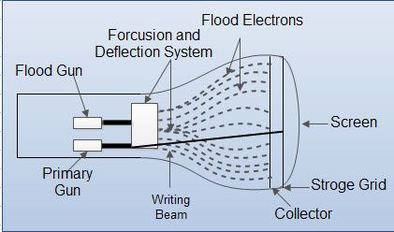

Thus, the electrons attracted by the positive charges pass through the mesh, travel on to the phosphor coated screen and display the picture. Since the collector has slowed the electrons down, they may not be able to produce sharp and bright images. To over come this problem, the screen itself is maintained at a high positive potential by means of a voltage applied to a thin aluminum coating between the tube face and the phosphor.

The dotted circle on the mesh is created by positive charges the flood of electrons hit the mesh at all points. But only those electrons that hit the dotted circle pass through and hit the CRT screen. The negatively charged mesh repels others.

Since the phosphor is of a very high persistence quality, the picture created on the CRT screen will be visible for several minutes without the need for being refreshed.

Now the problem arises as to how do we remove the picture, when the time for it’s erasure or modification comes up. The simple method is to apply a positive charge to the negatively charged mesh so that it gets neutralized. This removes all charges and clears the screen. But this technique also produces a momentary flash, which may be unpleasant to the viewer.

This is mainly so when only portions of the picture are to be modified in an interactive manner. Also, since the electrons hit the CRT screen at very low speeds (though they are slightly accelerated in the last part of their journey to the CRT by a positively charged aluminum coating), the contrasts are not sharp. Also, even though the pictures stay for almost an hour, there will be a gradual degradation because of the accumulation of the background glow.

The other popular display device is the plasma panel device, which is partly similar to the DVST in principle, but over comes some of the undesirable features of the DVST.

**Q - 6: EXPLAIN FLAT PANEL DISPLAY.**

ANS ->

Flat-Panel Devices are the devices that have less volume, weight, and power consumption compared to Cathode Ray Tube (CRT). Due to the advantages of the Flat-Panel Display, use of CRT decreased. As Flat Panel Devices are light in weights that’s why they can be hang on walls and wear them on our wrist as a watch. Flat Panel Display (FPD) allow users to view data, graphics, text and images.

**Types of Flat Panel Display:**

1. **Emissive Display:**

The Emissive Display or Emitters are the devices that convert electrical energy into light energy.

**Examples**: Plasma Panel, LED (Light Emitting Diode), Flat CRT.

2. **Non-Emissive Display**:

Non-Emissive Display or Non-Emitters are the devices that use optical effects to convert sunlight or some other source into graphic patterns.

**Examples**: LCD (Liquid Crystal Display)

**Advantages of Flat Panel Devices:**

* Flat Panel Devices like LCD produces high quality digital images.
* Flat Panel monitor are stylish and have very space saving design.
* Flat Panel Devices consumes less power and give maximum image size in minimum space.
* Flat Panel Devices use its full color display capability.
* Full motion video can be viewed on Flat Panel Devices without artifacts or contrast loss.

**Disadvantages of Flat Panel Devices:**

* They are very expensive compared to CRTs.
* They have very high refresh rates.
* Slow response times.
* They may be heavier and bulkier than other display types.

**Q - 7: EXPLAIN INPUT DEVICES.**

ANS -> <https://www.tutorialspoint.com/computer_fundamentals/computer_input_devices.htm>

**Q -8: EXPLAIN VIRTUAL REALITY SYSTEM.**

ANS -> <https://en.m.wikipedia.org/wiki/Virtual_reality>

**Q - 9: EXPLAIN RANDOM SCAN DISPLAY.**

ANS -> <https://www.geeksforgeeks.org/random-scan-display/>

**Q - 10: EXPLAIN RASTER SCAN DISPLAY.**

ANS -> <https://www.geeksforgeeks.org/raster-scan-displays/>